Navigating the digital shift: universities contributing to sustainable education and workforce preparedness
Pre-print notice
This is the author’s accepted manuscript. The article was peer-reviewed and accepted for publication, but was withdrawn by the author before publication due to changes in the journal’s indexing status. This version should be considered a pre-print. A revised version may be submitted to another peer-reviewed journal.

Guna Jakobsone-Snepste
dept. Institute of Digital Humanities
Riga Technical University
Riga, Latvia
Guna.Jakobsone-Snepste@rtu.lv
Janis Kapenieks
dept. Institute of Digital Humanities
Riga Technical University
Riga, Latvia
jkapenieks@gmail.com
Guillaume Deffuant
dept. LISC
INRAE
Clermont-Ferrand, France
Guillaume.Deffuant@inrae.fr
Atis Kapenieks
dept. Institute of Digital Humanities
Riga Technical University
Riga, Latvia
Atis.Kapenieks@rtu.lv
Lasma Ulmane-Ozolina
dept. Liepja academy
Riga Technical University
Riga, Latvia
Lasma.Ulmane-Ozolina@rtu.lv

Abstract — The focus of the research is the DigComp 2.2 framework (Digital Competence Framework for Citizens), an initiative by the European Commission that defines and categorizes the digital skills and competences necessary for active participation in a digital society. This research aims to enhance workforce skills by leveraging tools developed by higher education institutions, thereby ensuring the effective implementation of this framework for societal benefit. The research used Design Science Research (DSR) as its research methodology, which focuses on the creation and evaluation of artifacts designed to address specific identified problems. This methodology aims to provide practical solutions while contributing to both academic knowledge and real-world applications. Quantitative data processing method was also used. The research results indicate an increased availability and acceptance of learning at the DigComp 2.2 framework level. The main conclusion is that a timely response to the growing need for advanced digital skills is a critical task for modern universities. Recommendations – the permanent availability of advanced learning content, coupled with robust support systems, should be a key component of the social and economic ecosystem and sustainable learning in the digital age.
Keywords—DigComp 2.2, digital learning, digital skills, education technology, future learning, learning analytics, sustainable education, workforce.

Introduction
The Digital Competence Framework for citizens (Dig Comp 2.2) provides a common understanding of what digital competence is [1]. Dig Comp 2.2 is the latest version of the Digital Competence Framework for Europeans. It classifies the digital skills and competences that citizens need to use digital technologies and raise skills, including in data literacy and security. European Union for the Digital Decade Policy Programme 2030 has set ambitious policy goals to achieve - by year 2030 80% of the population has at least basic digital skills and has at least 20 million ICT specialist [2]. The first of these objectives is also included in European social rights the Pillar Action Plan [1]. Critical and responsible use of digital technologies is a necessity for the entire modern society. Dig Comp 2.2 supports educational and training programs in developing curricula that are relevant to the demands of the modern workforce, thus enhancing employability and participation in the digital economy.
Similar to our other research on e-learning technology and effective e-course development, this research aims to enhance workforce skills by leveraging tools developed by higher education institutions, thereby ensuring the effective implementation of this framework for societal benefit The target group of this study is non-IT students who need enhanced digital skills that meet the DigComp 2.2 framework and labour market requirements.
The student performance data before and after learning the e-content were used for knowledge acquisition model design. This model is based on the assumption that knowledge acquisition of real e-content can be quantified by superposition of the impact of learning “appropriate” content, too easy content, and too complicated content. The learner knowledge acquisition surface is calculated on this assumption. The data of real course learner knowledge acquisition are located on this surface as “telecides”. Telecides are the visualization of the appropriateness of an e-content unit for the needs of the specific learner or learners target group [3].
The second goal of the study is to ensure that an institutional self-assessment of digitalization is carried out at five Latvian Higher Education Institutions (HEIs). Within the framework of the EduAim project, the institutional self-assessment of digitalisation of Latvian Higher Education Institutions (HEI) is carried out twice. The first self-assessment conducted in January 2023, and the second - in December 2023. For this purpose, the “HEInnovate self-assessment (self-reflection) tool [4] is used, adapting the framework proposed by the European University Association (EUA).
The relationships discovered in the authors' previous studies and experiments are used in the development of e-study technologies, modernizing the content of e-study courses, and conducting new research. Understanding the relevance of specific knowledge in the context of online courses is important for the architecture of the content of the course and for improving the effectiveness of the learning process. By identifying the specific nature of the knowledge flow in a timely manner, it is possible to better adapt the course content to the needs of the student and to ensure that the time spent on learning is used effectively. In the case of this tailored course content, it is expected that in a given course, it would be possible to learn more content than a time-like course where knowledge stickiness has not been taken into account [5]. In particular, the authors use this method effectively for target groups in complex tasks, including increasing digital skills.
The increasing use of advanced digital technologies is transforming production processes and product development activities [6]. This industrial revolution is changing the nature of the job market, even simple physical jobs require digital skills. The DigComp framework is designed to help address the issue of improving the digital skills of society. The effects are expected to be radical, and are referred to as the fourth industrial revolution or “industry 4.0" [7]. This impact is inevitable.
The DigComp projects issued by the EU categorize digital literacy into five domains: information, communication, content creation, safety, and problem solving [8]. In the updated 2022 version of DigComp 2.2, the division of the big 5 categories is the same, but competence descriptions are supplemented with artificial intelligence skills. Maintaining the need to improve skills and competences that are relevant for the EU labour market and education and training [1].
The technology used in EduAim project is based on the previously developed and researched TELECI technology. ARTSS-EDU is its continuation, which will be used for EduAim activities - improving the digital skills of non-IT students based on the DigComp 2.2 framework. The user behaviour data generated in the TELECI learning environment with additional short, easy-to-use multiple-choice questions before and after each content subunit are used for visualization and correlation analysis [3]. EduAim courses were designed according to the ARTSS-EDU principle, which was developed in previous research and has proven itself to be a highly effective technological and content delivery tool for e-learning The e-courses used in the study were adapted to generate more user behaviour data in each course unit. This was ensured by the placement of relevant questions at the beginning and end of each topic [9]. The basic principle of the ARTSS-EDU approach: it must be compatible with existing study processes, students and lecturers must receive timely feedback at various levels of the study process, including the study program, study course and study course topic levels, and the problem of data overload must be solved, primarily providing the most important indicators of the study process. The ARTSS-EDU tool is a plug-in that can be used to expand the capabilities of the existing e-study environment, and it includes data extraction from the e-study environment, data transformation according to the ARTSS-EDU approach and data visualization [10].
Figure 1 shows the authors previous research and the development and implementation of new e-learning technology methods.
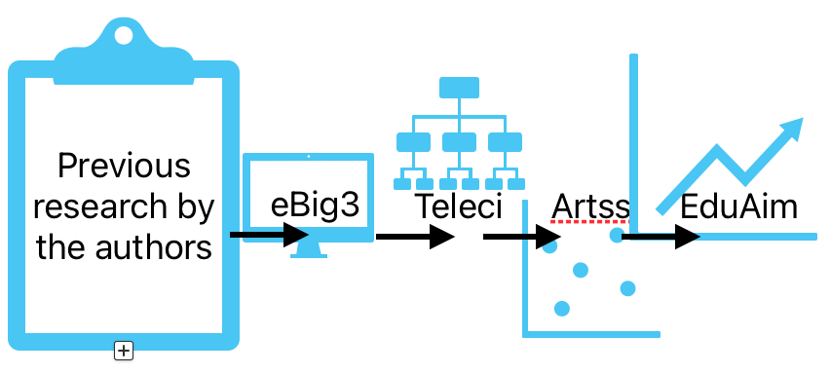
- Previous research by the authors.
The results of ARTSS-EDU study show that the knowledge flow is influenced by factors (stickiness and motivation) which are important for the development and improvement of e-learning. To provide better online courses and learning outcomes, it is essential to identify if there is any sticky knowledge in the knowledge flow. It is also important to motivate the students and to analyse their performance descriptors [11]. The authors use these research results in a study on improving digital skills.
Design Science Research (DSR) is a method that helps to solve the problems specified in DigComp 2.2. It helps to develop new methods and evaluate them, based on previous research and developed IT solutions.
Universities must ensure that new tools and methods are developed and implemented for the benefit of society.

Materials and Methods
The study on the contribution of universities to multimedia systems in education and workforce training uses a particularly useful methodology, Design Science Research (DSR), which promotes the creation of new strategies for solving practical problems in the fields of innovation and technology
The research used Design Science Research (DSR) as its research methodology, which focuses on the creation and evaluation of artifacts designed to address specific identified problems. This methodology aims to provide practical solutions while contributing to both academic knowledge and real-world applications. Quantitative data processing method was also used.
Design science is active with respect to technology, engaging in the creation of technological artifacts that impact people and organizations. Its focus is on problem solving but often takes a simplistic view of the people and the organizational contexts in which designed artifacts must function. The design of an artifact, its formal specification, and an assessment of its utility, often by comparison with competing artifacts, are integral to design-science research [12].
By coming together, researchers from 5 Latvian higher education institutions (Liepaja University - LiepU, Daugavpils University - DU, Rezekne University of Technology - RTA, Vidzeme University of Applied Sciences - ViA, Latvian Maritime Academy - LJA) identified shortcomings in the universities' existing digitalisation initiatives. A new course platform EduAim was developed and available to all participating universities, their students and anyone else interested in acquiring digital skills. EduAim includes teaching methods that will improve the effectiveness of multimedia education. Additional technological solutions - a series of tools are developed to monitoring the study process and promoting the learning process:
- Remote testing and knowledge assessment technology ARTSS,
- Knowledge perception monitoring,
- Student digital skills testing tool,
- Facial expression recognition tool,
- Reading Ease Tool,
- Virtual reality solution [13].
These digital tools help universities to enhance digital skills’ development for non-IT students. Technology and behaviour are not dichotomous in and information system. They are inseparable [12].
More than 1,000 students were involved in the piloting and testing of the platform, and more than 250 non-IT students have been awarded certificates for improving their digital skills. Obtaining a certificate is possible after a digital skills test before and after the course to determine progress, as well as after taking the final test of the course. At the end of the courses, students provided feedback on the EduAim courses and the course platform.
University researchers agree that the new platform and multimedia system tools effectively address the improvement of digital skills of non-IT students, in line with Dig Comp 2.2 guidelines and labour market needs. This is proven by assessments based on the results of the digital skills assessment tool and successfully passed exams.
In the project, support for lecturers was created, supplemented and improved during the entire project. All methodological materials for lecturers are available at https://eduaim.moodle.mii.lv in the section - EduAim consultative support for lecturers and content developers/methodological support package. Both before the first and before the second pilot, a presentation was created for piloting the courses. The presentation contains step-by-step directions for a student to start participating in EduAim courses.
EduAim has a positive impact on the learning outcomes and job market relevance of non-IT students.
The EduAim project assesses the Digital Transformation and Capabilities of five Latvian HEIs. The digital self-assessment of Latvian HEIs, as an aggregate category “Digital Transformation and Capability”, was being held in the following assessment sub-areas (sub-categories):
- The HEI fosters a digital culture and implements and monitors a digital strategy supporting innovation and entrepreneurship,
- The HEI invests in, manages and continuously improves a fit-for-purpose digital infrastructure,
- The HEI actively supports the use of digital technologies to enhance quality and equity in teaching, learning and assessment,
- The HEI actively uses open educational resources, open science and open data practices to improve the performance of the institution and increase its impact on its ecosystem,
- The HEI makes full use of its digital capacity to promote sustainable and inclusive innovation and entrepreneurship.

Results and Discussions

The digital self-assessment scores of universities in the evaluated category "Digital Transformation and Capability" and its sub-categories showed moderate progress that universities have made in organizations' digitization processes (for the category, 2.98 points in an average). It can serve as a kind of measure that gives an understanding of the steps taken by the HEIs towards their defined strategic goals, including digitization, attainment and the level of implementation. Table 1 clearly show the self-assessment of Latvian HEIs (Initial self-assessment carried-out at the first phase of the EduAim project, till January, 2023)
Table 1 Digital self-assesment of Latvian HEIs at the first phase
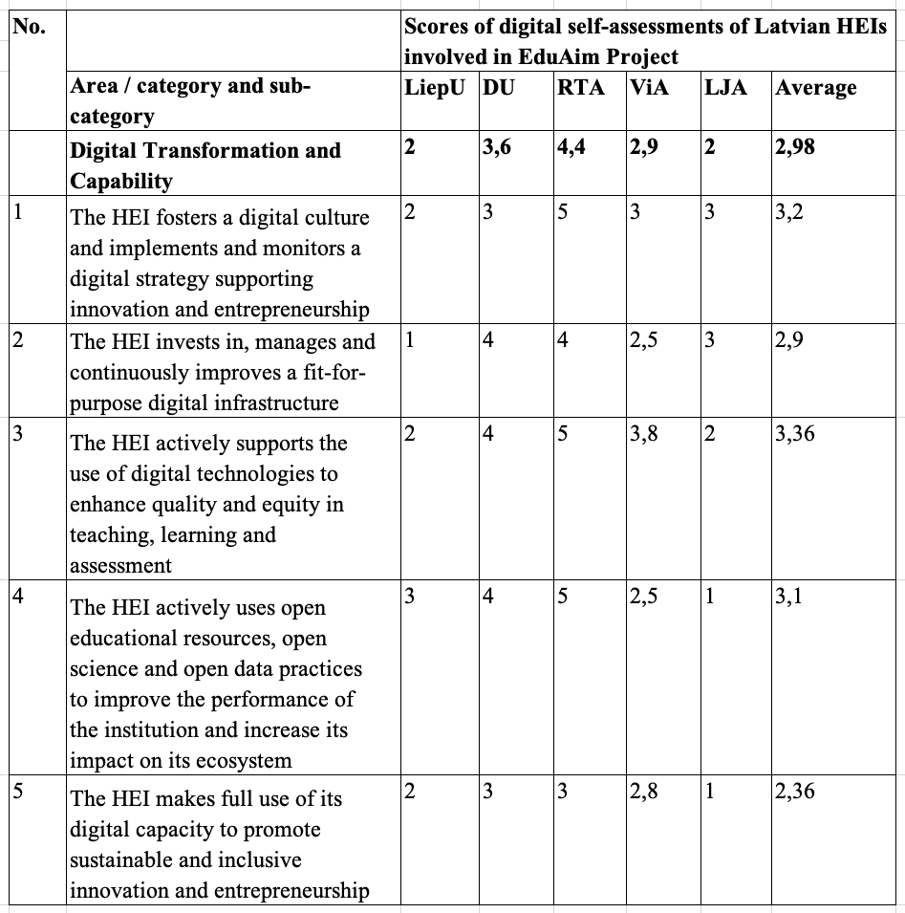
However, we can observe a wide diversity in this self-assessment results between universities. Namely, some universities, such as LiepU, RTU LJA (Latvian Maritime Academy (in Latvian: “Latvijas Jūras Akadēmija”) is incorporated in the RigaTechnical University during the implementation of the EduAim project. Therefore, in the text it isgiven an abbreviation - RTU LJA. In the tables and data visualization, the previous abbreviation of the university according to the one specified in the project application is indicated - LJA.) and ViA, ought to shed their low ratings in the area “Digital Transformation and Capability” (respectively: 2; 2; and 2.9 self-assessment points) in order to take measures to improve these indicators, achieve higher levels, and catch up with other universities. For instance, RTA has shown 4,4 self-assessment points and DU achieved 3,6 points. These scores are not surprising because RTA and DU are increasingly taking care of developing their scientific-research base and digitizing the study process.
Evaluating the first sub-category “The HEI fosters a digital culture and implements and monitors a digital strategy supporting innovation and entrepreneurship”, it should be concluded that the average score “3,2”, although at a sufficiently high level comparing to the average score of all subcategories here, has been achieved only thanking to the RTA results (the score "5"); lagging behind other universities (one score was just “2” and many others – only “3”). This indicates that the RTA pays sufficient attention to the promotion, implementation and monitoring of the digital strategy it has developed, which supports innovation and entrepreneurship, thus contributing to the further development of the HEI digital strategy and the promotion of digital culture. The other HEIs involved in the EduAim project would be advised to take a closer look at the digital strategy of their organizations and take measures to implement these digitization steps more effectively.
Table 2 show the second digital self-assessment of Latvian HEIs (the second self-assessment carried-out at the final phase of the EduAim project in December, 2023)
Table 2 Digital self-assesment of Latvian HEIs at the second phase
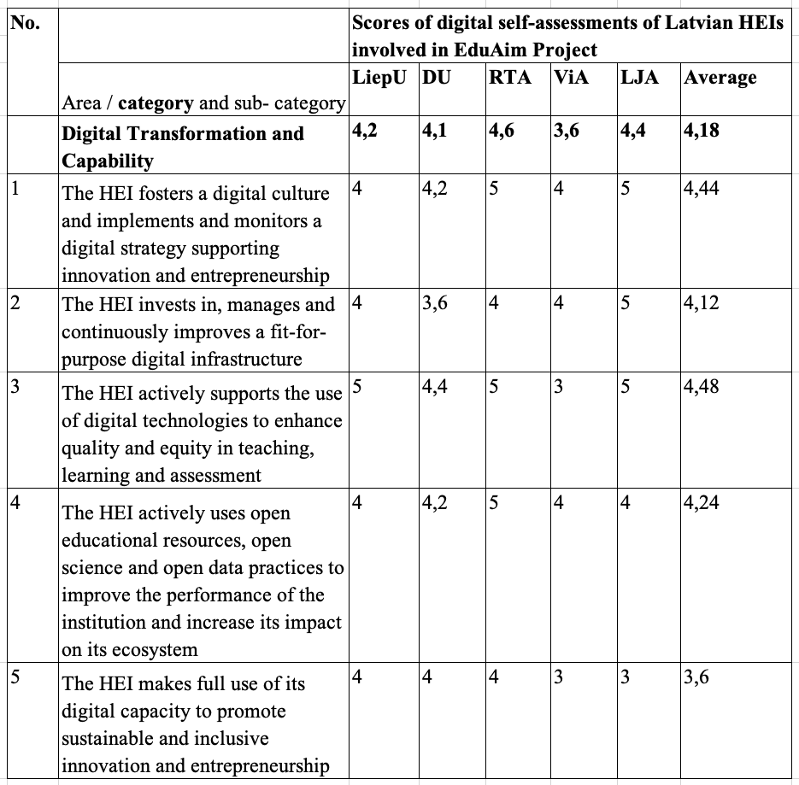
Comparing the results of the 1st and 2nd institutional digital self-assessment of Latvian HEIs, it could be concluded that the participation and active involvement in the EduAim project has allowed our universities to raise their digital awareness and self-confidence, as well as their level of abilities (primarily, in the field of education and research). Table 3 clearly show the progress made by universities during the implementation of the EduAim project.
Table 3 Comparison of two digital self-assesments of Latvian HEIs
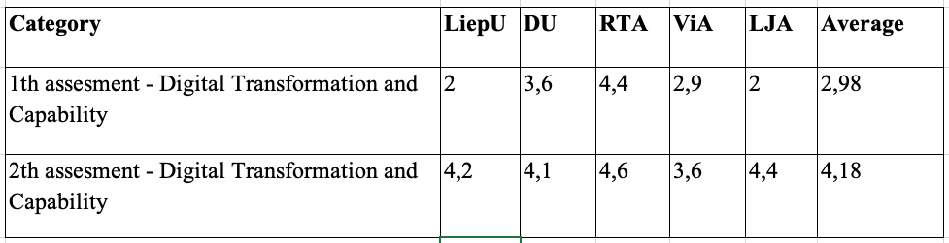
The research results indicate an increased availability and acceptance of learning at the DigComp 2.2 framework level. The main conclusion is that a timely response to the growing need for advanced digital skills is a critical task for modern universities.
EduAim platform and multimedia system tools are being evaluated by non-IT students after the pilot. The main finding is that students with lower digital skills appreciated the face-to-face meeting, during which they could, with the support of the lecturer, register on the EduAim portal, take the self-assessment tests and register for the course.
Students with higher digital skills rated the remote meeting and email communication more highly.
Student Digital Proficiency Test - before starting the e-course, the learner carried out a self-assessment of his/her digital skills using Fit4Internet, the tool chosen by the project partners. The questionnaire, hosted by an Austrian trader, is aligned with the DigComp 2.2 digital skills standard and follows the project's methodology of initially assessing the level of skills to be able to compare it with the results achieved after the course. The student is given a code to take a free self-assessment test and answer questions on ICT topics according to all five DigComp 2.2 competences. Unfortunately, during the process, it was revealed that the Fit4Internet surveys contained questions that were not directly related to Latvian digital systems, but specifically related to Austrian digital solutions, which Latvian residents were not informed about. This situation was taken into account and the tool was later adapted. In order to create a digital literacy assessment tool, it was decided to create a set of questions that could be used to select the most appropriate and relevant ones for the learning outcomes defined in each course. Initially, a set of self-assessment criteria for digital skills were developed. Then, based on this, questions for each of the five DigComp2.2 digital competencies sub-competencies have been developed, 273 questions in total.
The digital skills test in the five areas of DigComp 2.2 was meaningful for both the student and the lecturer. The student's self-assessment gave an idea of his/her digital skills level, while the lecturer was able to provide personalised learning activities by diagnosing the learners' digital skills level at the beginning of the course.
In the first phase of piloting, we found that the system was cumbersome – each document had to be downloaded in order for the lecturer to be able to review the self-assessments submitted. Therefore, solutions were sought to make this part easier for both the lecturer and the students. The project working group decided to develop a technological solution in Moodle that would allow self-assessments to be submitted in one place with the possibility for lecturers to see a summary.
In the first pilot phase, 6 lecturers participated with seven courses. The piloting took place in the spring semester 2023 from February to June. During the piloting of the courses, the methodological support of the lecturers was of particular importance for the success of the piloting.
The piloting of the course also revealed some issues that are being addressed during the second piloting. The second piloting of the courses planned in the project took place from 01.07.2023. until the end of the project.
In total, more than 250 students (excluding IT program students), including lifelong learning students, participated in the piloting of the courses. Evaluating the data obtained in the learners' self-assessment about their digital skills before and after taking the course, there is a tendency for students to improve their skills during the course. For example, for the courses included in the competence "Creating digital content", 86 learners filled out the Fina Questionnaire, and the results show that only 14% of the students admitted that there were no changes in their digital skills. The data show that the majority of students who noted that there was no change in their digital skills started their studies with a digital competence level of 4 or 5.

Conclusions
The permanent availability of advanced learning content, coupled with robust support systems, should be a key component of the social and economic ecosystem and sustainable learning in the digital age.
Digital assessment of universities is a critical component that contributes to the ability of educational institutions to respond to changing technological and educational needs, as well as helps develop a sustainable and effective strategy for the future. Incorporating evaluation into university strategies and using these strategies in decision-making helps make universities more attractive to students, apply the latest teaching methods, better plan investment priorities in the IT field, increase reputation, promote international cooperation, and respond to changing educational demands. Based on the analysis of the results of the institutional digital self-assessment of Latvian HEIs, have been submitted for their inclusion in the strategies of Latvian HEIs.
The authors believe that it is very important for Latvian higher education institutions, in accordance with the instructions included in the strategies, to that: Higher education institutions continue to use EduAim courses; Evaluate their digitalization development once a year; Update the importance of digital skills as a cross-cutting skill for lecturers.

ACKNOWLEDGMENT
This work has been supported by the European Social Fund within the project “Enhanced Digital Capacity for Universities by Smart Integration of On-Line Learning Resources and Analytics” (EduAim) No. 8.2.3.0/22/A/003 (REACT-EU) and by the European Union, HORIZON-WIDERA-2021-ACCESS-03-01, within the project “Twinning in Environmental Data and Dynamical Systems Modelling for Latvia” No. 101079206.
REFERENCES
- R. Vuorikari, S. Kluzer, and Y. Punie, Y., DigComp 2.2: A Framework for Digital Competences for Citizens, EUR 31006 EN, Publications Office of the European Union, Luxembourg, 2022, ISBN 978–92–76–48882–8, DOI: 10.2760/115376
- EP, E. (2022). Decision (EU) 2022/2481 of the European Parliament and of the council of 14 December 2022 establishing the digital decade policy programme 2030. Official Journal of the European Union
- A. Kapenieks, I. Daugule, K. Kapenieks, V. Zagorskis, J. Kapenieks Jr., Z. Timsans, I. Vitolina, “TELECI Approach for e-Learning User Behaviour Sata Visulalization and Learning Support Algorith”, Baltic J.Modern Computing, Vol.8 No 1, p. 129-142, 2020. Available: bjmc, https://www.bjmc.lu.lv/fileadmin/user_upload/lu_portal/projekti/bjmc/Contents/8_1_06_Kapenieks.pdf[Accessed Dec. 24, 2024], DOI:10.22364/bjmc.2020.8.1.06
- HEInnovate, an initiative of the European Commission's DG Education and Culture in partnership with the OECD, Available: HEInnovate, https://heinnovate.eu/en [Accessed Dec. 24, 2024].
- A. Robinson, D.Cook, “”Stickness”: gauging students’ attention to online learning activities” Information and Learning Sciences 119 (7/8), August 2018, Available: pen, https://pen.ius.edu.ba/index.php/pen [Accessed Dec.24, 2024].
- M. Capestro, S.Kinkel, (2020). Industry 4.0 and Knowledge Management: A Review of Empirical Studies. In: Bettiol, M., Di Maria, E., Micelli, S. (eds) Knowledge Management and Industry 4.0. Knowledge Management and Organizational Learning, vol 9. Springer, Cham. https://link.springer.com/chapter/10.1007/978-3-030-43589-9_2
- K. Lichtblau, V. Stich, R. Bertenrath R. Blum, M. Bleider, A. Millack,… M. Schröter (2015) IMPULS-Industrie 4.0-Readiness. Impuls-Stiftung des VDMA, Aachen-Köln
- A. Ferrari, “DIGCOMP: A Framework for Developing and Understanding Digital Competence in Europe”, European Commission, Joint Research Centre, Institute for Prospective Technological Studies, 2013.
- A. Kapenieks, I. Daugule, K. Kapenieks, V. Zagorskis, J. Kapenieks Jr., Z. Timsans and I. Vitolina, “Knowledge Acquisition Data Visualization in eLearning Delivery”, In Proceedings of the 12th International Conference on Computer Supported Education - Volume 2: CSEDU; ISBN 978-989-758-417-6; ISSN 2184-5026, SciTePress, pages 507-513.https://www.scitepress.org/Link.aspx?doi=10.5220/0009803505070513, DOI: 10.5220/0009803505070513
- National research program, Report: "Proposals for Monitoring Learning Analytics in Higher Education", 2022. Available: Artss, https://artss.rtu.lv/lv/rezultati/priekslikumi-macisanas-analitikas-monitoringam-augstakaja-izglitiba [Accessed Dec.27, 2024].
- I. Daugule, A. Kapenieks, “Collaborative knowledge flow – mapping the e-learning environment”, EDULEARN17 Proceedings, p. 3304-3311, ISBN: 978-84-697-3777-4, ISSN: 2340-1117, doi: 10.21125/edulearn.2017.1708
- A. R. Hevner, T. S. March, J.Park, S. Ram, “Design Science in Information Systems Research”, MIS Quarterly Vol. 28 No. 1, pp. 75-105/march 2024. Available: Wise, https://wise.vub.ac.be/sites/default/files/thesis_info/design_science.pdf [Accessed: Dec. 27, 2024].
- European Social Fund project “Enhanced Digital Capacity for Universities by Smart Integration of On-Line Learning Resources and Analytics (EduAim)”, 2023, Available: EduAim: https://www.eduaim.eu/tools [Accessed: Feb. 23, 2025.].
A

